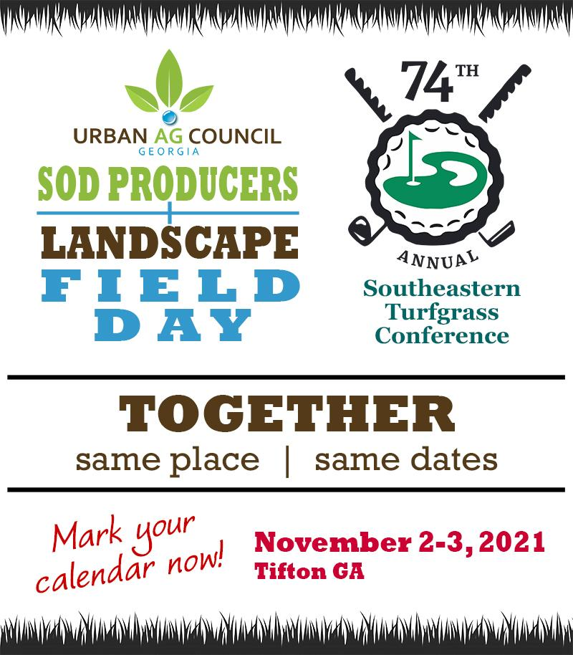

Breaking news!

The Georgia Sod Producers Field Day & the 74th Annual SE Turfgrass Conference will combine on Nov 2-3, 2021, live in Tifton, GA!

We are excited about this event - by Nov we should all be in great shape & health to visit in person!

Save the date-more details to come!

